Kickstart your career
About the Course
If you’re a student, graduate or new entrant in the mining industry, this course is for you. It will provide a refresher on geological techniques used in the industry, as well as hot new topics in geoscience. For those who routinely bunked their geology classes, it will probably all be hot new topics!
In addition, don't get caught between a rock and a hard place: learn how to catch the eye of the recruiter (in the CV sense), crack the interview and shed those pre-conceived ideas about mentoring.
And all this while feeding you quiche and beer. What do you mean, real geologists don’t eat quiche!?
If beer didn't convince you to sign up, then the 20 CPD points you could earn toward your professional development should seal the deal.

Programme
As per the excel spreadsheet

Abstract and Presenter Information
- Geology; a rocky career
Geologists are 'scientists' obsessed with rocks. Often too intelligent to do dull sciences like biology, chemistry, or physics, geologists devote their time to volcano poking, fault finding, obscure folding, rock-collecting, and high-risk colouring.
But are these the only options open to us unique professionals? I think not!
Filched from http://uncyclopedia.wikia.com/wiki/Geologist
Noleen Pauls – Independent Geological Consultant
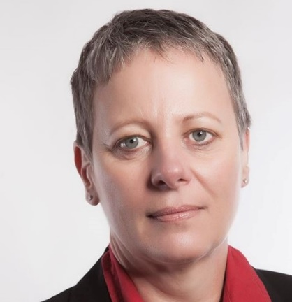
Noleen Pauls has over 20 years’ experience in the management of gold, platinum, chrome, iron ore and coal exploration projects in Africa and South America. In addition, she has been involved in site evaluations, due-diligence work, supervision and preparation of tender documentation, and extensive multi-commodity mineral rights management, which includes applications, and management of technical and environmental compliance.
Along with a career in Geology, her interest and passion lies firmly in the mentorship and development of young people entering the professional arena of Mining and Geology, enabling and equipping them to navigate this world professionally and personally. To this end, she has elected to consult as a freelance professional giving her time to engage more freely in this aspect of the mining world.
Noleen is a WiMSA patron, sits on the committee and was the chairperson from January 2014 to December 2016. She is a fellow and council member of the Geological Society of South Africa and registered with the South African Council for Natural Scientific Professions.
- Knowledge-hungry millennials in mining
Millennials often viewed with a negative connotation as arrogant, entitled, lazy, immature and inexperienced. It doesn’t have to be so. With the continued economic crunchy and technology disruption abuzz everywhere, tech-savvy and knowledge hungry millennials have so much to offer the mining industry.
As the industry struggles and looks for ways to climb out of this recent slump, many believe technology will lead the way, and technologically fluent millennials will be essential to this transformation. Do not underestimate your value and ability to contribute. Embrace the fact that, as millennials, you are curious, able to learn anything you like very quickly. As a result, you may have innovative ideas that the industry would have never thought of. Embrace your knowledge and the experience of the baby boomers and, together, you can continue to drive SA’s mining industry forward.
Dr Muriel Chinoda – Managing Director of The Business Engine
With more than 15 years’ experience as a business strategist and consultant, Muriel has spent a lot of time in the boardrooms of many companies around the world. She is a serial entrepreneur and a frequent speaker at corporate events.
A holder of a Doctoral of Business Leadership, a Master’s in Business Leadership and a Bachelor of Electronic Engineering Hons degree, and various other qualifications, Muriel is a strong proponent of good education as a tool that if used correctly can liberate Africa and humanity.
In between her busy schedule, Muriel finds time for her favorite pastime, exploring the world and seeing faraway places. She enjoys experiencing other cultures and enriching herself in the process.
Her motto in life is “Limiting the amount of success you desire, is robbing the world of the talents and gifts that others could have enjoyed from you. So, live an ignited life – A life true to only you!”
- What can I offer the Mining Industry? – An Entry/Exit Strategy
The Mining Industry of today is a much-changed landscape to what it was 20 years ago where half of the graduates entering the Mining Industry were bursars; the other half expected to be employed within 6 months of their graduation. Nearly everyone that got employed expected to go through some form of Graduate-In-Training program. Within 5 years of employment many expected to be fast-tracked into a management or semi-management role.
A combination of factors, including low metal prices, global economics and geopolitics, and a shrinking traditional mining industry, have combined to change the employment landscape for todays’ graduates. Increasingly, the graduate is faced with the question of if, not when, they can make Mining a career. Those who do get employed can expect to go through at least one retrenchment cycle in the first 5 years of employment. Those who stay employed are faced with poor on-the-job-training, little or no mentorship, social and economic challenges. Employers are increasingly looking for not just smart employees but job-ready, smart and well-rounded and technically aware candidates.
With all these challenges, how does one enter the Mining industry? How does one stay employed, and if need be how does one plan to exit the industry at the appropriate time? Here we present an entry/exit plan strategy for the young employee.
Benny Chisonga – Geologist at Datamine
Benny is a geologist with experience gained working for the Geological Survey Department of Zambia, Vale, Anglo American, Snowden and Datamine, as well as the University of Johannesburg. Benny has experience in various commodities including ferrous metals, base metals and diamonds. He has undertaken Geological Modelling and Resource Evaluations, Technical Reviews and been involved in field exploration. He leads a small team of geologists at Datamine focussed on Operational Geology consulting, software and support throughout Africa. He has a PhD in Economic Geology from the University of Johannesburg.

- Mentors: A Heroes’ Journey
From the dawn of time skills and knowledge have been transferred from the older to the younger generation. As technology has developed, the ability to milk a cow or prepare a pig for slaughter has been replaced with the demand for new skills.
As we enter in to the “The Fourth Industrial Revolution*”, where globalisation and technological advances continue to shape the requirements of economies based on information; how do you transform terabytes of raw data into information? And how does information become knowledge that you can use to make informed decisions with? How do you maintain your “edge” in a rapidly shifting market, where skills become obsolete overnight and where a Master’s degree may only be relevant for five years….? The division of labour has resulted in highly specialised areas of expertise being developed, however the invisible hand! still dictates in a world built on supply and demand (or at least the perception thereof).
It is not, however, self-evident that the dictum of “knowledge = power”, has ceased to exist, being replaced by the concept of Emotional Intelligence (EI). Research undertaken by Daniel Goleman# indicated that EI accounted for 67% of the abilities deemed necessary for superior performance in leaders, and mattered twice as much as technical expertise or IQ.
With the mining industry opening up to the concepts of “diversity” and “inclusivity”; more groups, who do not have an historical industry background are being drawn into the industry; however, without the necessary guidance and mentoring failure is almost certain (Peter Principle$; Dunning–Kruger effect%).
This presentation will provide some guidance to the young practitioner who would like to develop a career in the mining or earth sciences and how some common mistakes can be avoided.
* Klaus Schwab - The Fourth Industrial Revolution
! Adam Smith - An Inquiry into the Nature and Causes of the Wealth of Nations
# Daniel Goleman - Emotional Intelligence: Why It Can Matter More Than IQ
$ Laurence Peter - The Peter Principle: Why Things Always Go Wrong
% Justin Kruger and David Dunning- Unskilled and Unaware of It: How Difficulties in Recognizing One's Own Incompetence Lead to Inflated Self-Assessments. Journal of Personality and Social Psychology. 77 (6): 1121–34.

Mark Burnett - Principal Consultant: Applied Geosciences at Snowden Mining Industry Consultants (Pty) Ltd
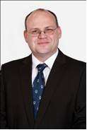
Mark has over 21 years of experience in mine geology and mineral resource estimation. Mark specialises in Mineral Resource Management in a production environment and has specific expertise in geological modelling, resource estimation, mine planning, independent technical reviews and audits, due diligences and grade control.
Since joining Snowden in 2007, Mark has worked on various deposit and mineralisation types, including shear zone hosted gold, uranium (granite and calcrete hosted), coal (thermal and metallurgical), phosphate, (sedimentary, marine and hard rock), potash, rare earths, graphite and base metals.
As part of his role as Principal Consultant, Mark also presents Snowden’s professional development courses.
- Remote sensing geology. How to map before you map.
Remote sensing methodologies offers a unique insight into an area prior to commencement of field work. Utilization of these techniques may allow for significant saving in time and resources during the mining cycle. During the talk, we will endeavor to highlight these methodologies as well as recent developments in remote sensing platforms and capturing methodologies. Access to data and processing software will also be discussed.
Andries Botha
- Mapping; are we or software the tool?
Geological mapping has evolved from the traditional systematic foot slog, hammer and notebook in hand, aerial photos with your hand-written annotations being protected from the elements prior to returning to camp and transfer of the precious data to field sheets utilizing the very same pen, to a digital workflow that links seamlessly through software into the final map making. But have the fundamentals of the science really changed?
Nick Baglow – Manager of Limpopo Regional Office, Council for Geoscience (CGS)
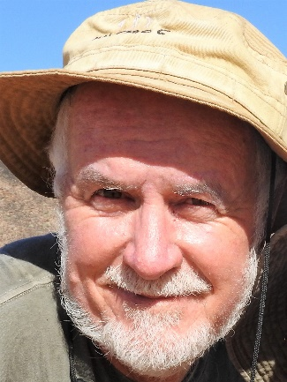
Nick is currently the manager of the Limpopo Regional Office of the Council for Geoscience. He has been involved in survey geological mapping most of his working life, from being sent out raw in the early 1980’s to now often doing the sending!
Field work for regional mapping projects has taken him to various parts of Africa and exposed him to life-enriching experiences that only our continent can offer. He presently also runs the annual CGS Field School.
- Sampling: a small part of the whole
Deon du Plessis – Earthlab

- Drilling techniques and sampling methods
Drilling is an integral part of understanding the geology in 3D and getting samples from down deep. We’ll explore when to use what drilling, how to do so safely and how to get the best information from your samples.
Russell Johnson - Senior Exploration Geologist at The MSA Group
Russell has managed a number exploration and resource drilling projects, including in the Barberton greenstone belt and Vredefort impact crater for research purposes, the uranium bearing sheeted leucogranites from the Rossing South uranium deposit, a regional overview of uranium-copper-cobalt deposits associated with the Damara Orogeny and Lufilian Arc in Namibia, Botswana, Zambia and DRC, orebody characterisation of two copper-cobalt deposits in the DRC, geological mapping of graphite bearing granites in the Cabo Del Gado Province of Mozambique, nickel and gold-bearing units in Central Saudi Arabia and coal-bearing horizons in Tanzania and IOCG/Hydrothermal copper exploration in Zambia.

- Real need for quality “Structural Geology”
Kevin Peyper - Operations Manager for Southern & Central Africa at REFLEX

- Life of a geoscientist in the modern exploration environment
What is the modern exploration environment really like? Letticia will discuss shifting from being a geologist/geophysicist to being a geoscientist, what life in a Greenfields exploration camp is like, and what the challenges of being a woman in exploration is.
“From the dawn of time skills and knowledge has been transferred from the older to the younger generation. As technology has developed, the ability to milk a cow and prepare a pig for slaughter has been replaced with new skills.
Letticia de Nysschen – Geophysicist at Rio Tinto Mining and Exploration
Letticia is currently a geophysicist at Rio Tinto Mining and Exploration. She is part of the generative team, focussed on generating new exploration projects in Africa as well as supporting existing projects in Africa and Eurasia. Before joining Rio Tinto, Letticia spent two years working as a research and development geophysicist at De Beers Marine where her focus was on very shallow marine seismic data processing, attribute analysis and interpretation. She also spent 7 years at the Council for Geoscience where she worked in the Petrophysical laboratory as well as doing ground geophysical work (mainly EM, mag and gravity data acquisition and processing).

- How geoscientists can work effectively with a geochemistry laboratory
Geological field work involving sample collection and drilling constitutes a significant portion of any exploration budget. Therefore, outcome of assays from the laboratory are crucial and extremely important to the success or failure of any geological exploration programme. Consequently, a geochemistry lab forms an important part of an exploration project, as laboratory assays are used to calculate ore resources and reserves. For any geochemical laboratory to achieve results that are compliant with ore reserves or resources reporting standards such as JORC, SAMREC, SME and NI43-101, it must follow global best practices through use of protocols and QAQC standards. This talk will take you step by step on how a geoscientist can obtain the global best practices from a geochemical laboratory.
Vincent Simumba - Business Development Manager in Geochemistry for Sub-Saharan Africa at ALS Minerals
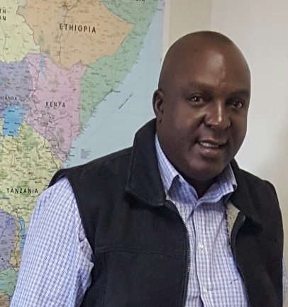
Vincent is responsible for marketing geochemistry services in Sub-Saharan Africa. Since obtaining a Bachelor of Mineral Science Geology degree from the School of Mines at UNZA in 1988, he worked as a Senior Project Geologist for Konkola Copper Mines in Zambia. He also worked for Boart longyear as Drilling Manager prior to a stint as Senior Project Geologist at The MSA Group. Before joining ALS in 2015, he spent five and a half years at Intertek Minerals as Business Development Manager responsible for Eastern, Central and Southern Africa.
In addition to his Geology degree, he holds a certificate in Project Management from Gibs School of Business, University of Pretoria.

- Go big or go home
Data management is an ever-evolving critically essential part of exploration and mining. Understanding your data allows you to make informed decisions and add significant value to a project. In this talk we will look at where we have come from, where we are and what we are currently doing with our data, and where we are going.
Philip Setzer – Database Administrator for Maxwell Geoservices
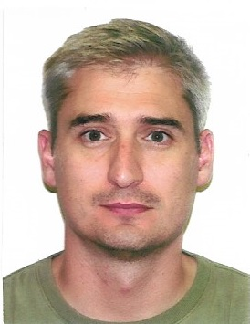
Philip is a Database Administrator for Maxwell Geoservices and has filled that role, among others, for several mining companies and exploration consultancies over the past 15 years.
He has a BA(Hons) in Environmental and Geographical Studies majoring in GIS and Remote Sensing, and a BA(Hons) Archaeology from the University of Stellenbosch.

- A picture is worth a thousand words
Are projections and co-ordinate systems more about guessing than knowing? Do you wish your maps looked better? This talk will give you the tips and tricks to become GIS savvy.
You’ll learn about GIS as a system for capturing, storing, manipulating, analysing, managing, and presenting spatial data. And about GIS applications that allow you to create interactive queries, analyse spatial information, edit data in maps, and present the results of all these operations.
Alan Goldsmith – Managing Director at Horizon Geomatics
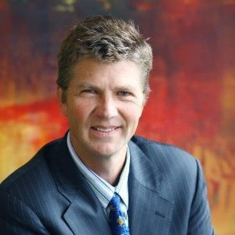
Alan joined Anglovaal Ltd after emigrating from the UK in 1991. He was involved in brownfields exploration in the Barberton Greenstone Belt, greenfields base metal exploration in the Damaran Orogenic Belt in Namibia, and deep drilling programmes for Witwatersrand Gold, developing conceptual models and undertaking project reviews for base and precious metals in many African countries, and some further afield.
While with Anglovaal, he designed, implemented and managed GIS for the mineral exploration department and remote regional offices, as well as integrating GIS into other disciplines such as the legal, environmental, and engineering departments.
Alan has been consulting as a geologist and GIS analyst to the exploration and mining industry throughout sub-Saharan Africa since 2001, both within a consulting company and independently.

- Get a feel for your data & unlock the hidden treasure therein
This talk will cover Exploratory Data Analysis (EDA), both geological and assay data, highlighting what can be uncovered with the right tools and some insight into the interpretation of results.
Christina Dohm - Visiting Professor School of Mining, University of the Witwatersrand
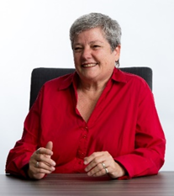
Christina has 37 years’ experience in the mining industry. She has been involved in Mineral Resource Management, Mineral Resource Evaluation & Classification, Independent reviews and the Corporate Governance associated with Competent Persons Reports on Mineral Resources and Mineral Reserves (R&R) Reporting Mining Operations and Projects worldwide of commodities such as Coal, Gold, Uranium, Platinum, Cobalt, Copper, Molybdenum, Zinc Lead, Nickel, Iron Ore, Manganese, Niobium, Phosphates, and Diamonds.
She has been a lecturer for the past four decades at various South African universities and continued lecturing and supervising post-graduate students in Geostatistics and MRM since her retirement form Anglo American at the end of 2015.

- Where does all the data go?
Data in the mining industry is equivalent to money in your bank account. The correct use and application of the data can drastically change your geological model. Geological models have evolved over time from back of the matchbox calculations, generating cross sections and triangulation by hand, to implicit modelling. The evolution driven by requirements for more flexible, cost effective solutions.
Siobhan Joubert – Independent Consultant
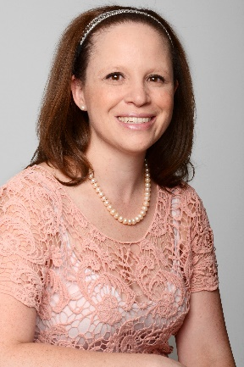
Siobhan is a geologist with a focus on resource geology and data management. Siobhan completed her BSc. Geology Honours degree at the University of Pretoria and went on to further her academics to include a GDE through the University of Witwatersrand and later completed the Citation Course for Applied Geo-statistics through the University of Alberta. Siobhan is a geologist with over 11 years’ experience and has held several positions in Mining Consultancies since 2016 including that of Divisional Leader: Resource Geology with Golder Associates Africa. She has a keen interest in corporate governance and data analysis and loves solving challenging problems.
She holds the Membership portfolio for WIMSA, and her desire is to reach out and empower women in the mining industry.

- Has the final environmental TRUMP card been played
The basis of the talk comes from Section 24 of the Constitution of the Republic of South Africa (1996): Everyone has the right to an environment that is not harmful to their health or well-being; and to have the environment protected, for the benefit of present and future generations, through reasonable legislative and other measures that prevent pollution and ecological degradation; promote conservation; and secure ecologically sustainable development and use of natural resources while promoting justifiable economic and social development.
Just as every person has a right to an environment that is not harmful to our health or well-being, so every person has a responsibility to adopt practices that support a safe, healthy and sustainable environment. One phrase we can take out the constitution that works towards the future is “sustainable development” and which includes topics such as: Governance; Environmental; Social; and Economic. In governance, I have the responsibility as a citizen in South Africa to have a symbiotic relationship with the environment (for future generations) which helps us to develop our resource by balancing the components of sustainability: Environmental Accounting (Economics – Environment); Socio Environment (Social – Environment); and Socio Economic (Social – Economics). The complexity of aforementioned does not lie in the process, but in people’s understanding, perceptions, reactions and interactions.
Let’s look at a practical example of building a facility and doing work in a mangrove (real project in Mozambique) and the social, environmental and economic interactions on the project.
Jacques Harris - Group Environmental Manager at GCS
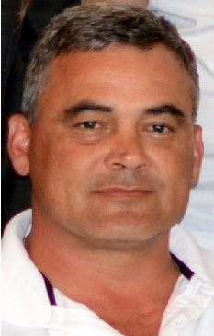
Jacques has over 21 years’ experience in the management of several diverse projects and programmes related to the Environment, Social, Waste, Health and Safety, Risk, Manufacturing, Marketing and Technology development. He has been actively involved with Environmental Management for the last 21 years, starting when he designed and operated a waste water facility for Saint-Gobain Abrasives.
As one of his major achievements at Saint-Gobain Abrasives, the South Africa business was awarded a Saint-Gobain Diamond award for the best Environmental, Health and Safety facility out of 320 facilities in the Global arena.
In 2009, he was appointed as Environmental Project Manager for Kwezi V3 Engineers (later WorleyParsons RSA) and has managed several large environmental projects. His experience includes various large renewable energy plants (CSP and PV), waste to electricity plants, anaerobic digesters, hydrocarbons oil tank farm and many infrastructure facilities’ environmental and social impact assessments. He also completed a large social assessment for the Department of Transport where he did a study on the socio-economic benefits of roads on the South African economy.
Jacques’ experience includes over 30 closure and closure liability projects for the mining sector (Deloitte, PWC and KPMG audited), financial risk modelling for several PPP and financial projects for local and provincial governments in South Africa.

- Professional reporting practices - the importance of being compliant (what's in a name?)
The SAMREC Code sets out minimum standards, recommendations and guidelines for Public Reporting of Exploration Results, Mineral Resources and Mineral Reserves in South Africa. This course will introduce the participants to the various aspects of compliance reporting.
Tania Marshall – Owner of Explorations Unlimited
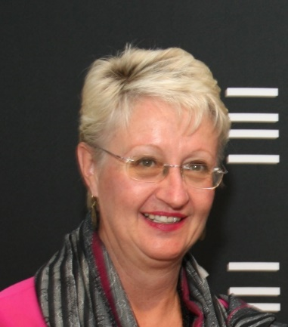
Tania has been actively, and continuously, involved in the alluvial diamond exploration/mining industry since 1985. She has worked directly for both large and small companies in this field, as an operator, and as a consultant (in Africa, South America, Australia and Asia), but has knowledge and experience in the deposits of the North West and the Northern Cape provinces of South Africa.
She has a PhD from the University of the Witwatersrand (1990). Since then she continues to write and lecture widely about alluvial diamond deposition, exploration, evaluation and valuation, in which fields she enjoys an international reputation. In 1996 Dr Marshall founded Explorations Unlimited and has been involved in consulting and contracting to numerous South African and international exploration and mining companies.
Tania is a Fellow of the Geological Society of South Africa and registered with the South African Council for Natural Scientific Professions (SACNASP) since 1996. In addition, she is an active member of both the SAMREC and SAMVAL Committees, chairs the SAMREC Diamond Working Group and is the incumbent Chairperson of the SAMCODE Standards Committee (SSC).

- A game of 30 seconds
Recruiters have 30 seconds to decide whether your CV gets the nod. Use those 30 seconds wisely and don’t end up in the trash!
Dr Janet Viljoen – Research Consultant at Janet Viljoen Consulting
Janet has a PhD in the Sciences, where she planned and managed an exercise intervention which approached the potential role of exercise (strength training) in mitigating chronic disease in a novel way. Skills developed during this time included project management, client liaison, presentation ability, and financial planning.
She is a passionate thinker with a developed sense of humour and lots of common sense. A natural leader, she is primarily a macro-thinker and able to manage both people and projects effectively through careful planning and respectful motivation.
She currently specializes in bespoke research solutions and workshops on topics ranging from Application of the Scientific Method, Research Ethics to reviewing the literature and writing skills for academic or business purposes.

- 8 ways (or more) to ace your interview
Whoop! Whoop! You've been invited to an interview for your first job! Well done! So now what? In half an hour, I am going to give you 8 tips on things to do before, during and after the interview that will give you a better chance of getting the job - or at least getting to the second round of interviews! It may be the last talk of the day, but it will be well worth waiting for!
Briony Liber – Owner and coach at Think Action Coaching
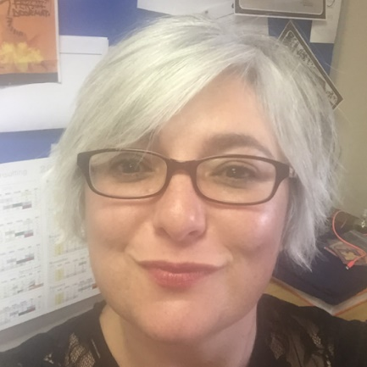
Briony is passionate about the development of leadership and management skills of young professionals. Her mission is to help young professionals and future leaders to build a personal brand that gets them noticed for the right reasons.
Her 18-year career in the mining sector as an environmental and social consultant, management of a team of environmental and social scientists, her professional consulting work in environmental, social and governance due diligence projects, coupled with her business diploma and coaching training and her own personal values, equip Briony to be people centered, passionate about self-development and learning, an innovative thinker, solutions focussed and action oriented.
Briony believes that professionals and consultants have the challenge (and opportunity) of having to perform as a “business within a business”, which requires substantially more than technical competence and delivery - and that is relevant all the way back to your first interview.

- Logging; the core of the matter
This presentation deals with standardization of geological core logging in the Minerals Industry. The subject is important for all geologists involved in logging and sampling drill core – especially for mineral evaluation. Too often important parameters are ill-described or even omitted from logs. The basic parameters are discussed, followed by tips and tricks for effectively capturing meaningful data. While a computer database is recommended, the concepts are universal and not platform dependent.
Rodney Tucker – Independent Consultant
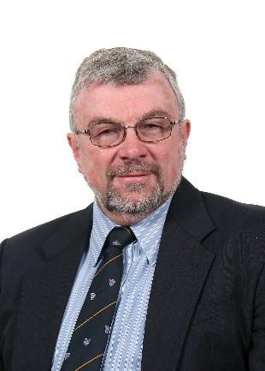
Rod received a BSc (Eng) degree in Mining Geology at the University of the Witwatersrand in 1970. He worked for JCI exploration before doing mine geology on Randfontein Estates Gold Mine. Here he did an MSc on sedimentological, mineralogical, geochemical and multivariate statistical aspects of the Composite Reef. He joined Anglovaal Limited as Group Sedimentologist, and later was appointed Exploration Manager for Avgold Limited. He then became Divisional Manager Exploration for Snowden Mining Consultants before starting up Kernow Exploration (Pty) Ltd as Managing Director. He was involved in successful exploration ventures for Witwatersrand gold, Bushveld platinum and Kalahari manganese in addition to a number of projects across Africa.
Rodney served on the Council of the GSSA and was President in 1997/98. He is a Life Fellow of the GSSA, a Retired Fellow of the SAIMM and was elected a Fellow of the SEG in 1997. With his keen interest in sedimentology, he served as Regional Representative of the IAS for Southern Africa. He designed and ran a SACNASP accredited Scientist-in Training scheme for Anglovaal geologists.
He was one of the originators of the SABLE borehole logging system, and has been a proponent of standardisation in borehole logging for many years.

