Mineralogical Association
of South Africa
A specialist Division of the Geological Society of South Africa
www.gssa.org.za/minsa
Membership Form

Mineralogical Association of South Africa
PO Box 21290
Helderkruin
1733
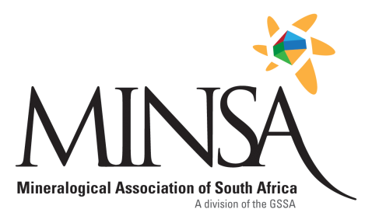

Title |  | Surname |  |  | First Name
Company / Institution
Job Title |  |  |  | Student Number (if applicable)
Postal Address
 |  |  |  |  | Postal Code
Email Address/es |  |  |  |  | Cell Number
GSSA membership number (if applicable)
Signature |  |  |  | Date

 | Proposer* | Seconder*
Full Name
Postal or Email Address
Signature
*To be Minsa members
Please pay by cash, or by electronic transfer, using your surname as reference,
and email confirmation to minsa@gssa.org.za
Bank: Absa, Account no: 21095311, Account type: Deposit
Branch: Clearwater Mall, Roodepoort,
Account Name: Mineralogical Association of South Africa.
Queries can be directed to minsa@gssa.org.za

